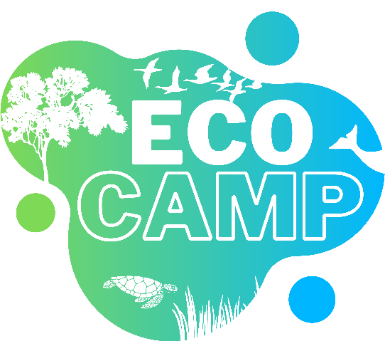
Hosted by Grenada Fund for Conservation Inc., and supported by Sandals Foundation
Dates: Monday 11th to Friday 15th July 2022
Time: 9 a.m. to 3 p.m. daily
Location: PAM Building, Mt. Parnassus

Registration Form

Child name:
Date of birth:
Address:
School and grade/form:
Parent/guardian name:
Emergency contact #:
This camp will involve daily outings possibly including nature walks, birdwatching, tree planting, and a boat ride on the final day. Does your child have any medical conditions we should know about?
Medical conditions:

Lunch and a snack will be provided each day for all participants. Does your child have any food allergies we should know about?
Allergies:

The camp registration fee is $60. This covers the cost of a camp t-shirt and a contribution to outings.
Child t-shirt size (letter and/or number size):

The deadline for registration and fee payment is Friday 1st July. There are two ways to submit this form: soft copy by email to gfcinc1@gmail.com or hard copy to Mr. Tyrone Buckmire at Legal Aid and Counselling Clinic on St. John’s Street in St. George’s.
Feel free to direct any questions to the email above, to Grenada Fund for Conservation on Facebook, or call/WhatsApp 404-0235.

Please note: our team will do all that is reasonable and practical to ensure the safety of camp attendees. This requires cooperation and obedience from all attendees, especially during outdoor activities. Any unruly or disruptive children will be asked to leave the camp, as we cannot take responsibility for their actions and any negative consequences. By signing below, you agree to these terms.

_____________________________________________ _____________________
Parent/guardian signature Date

